Motorist Awareness Division
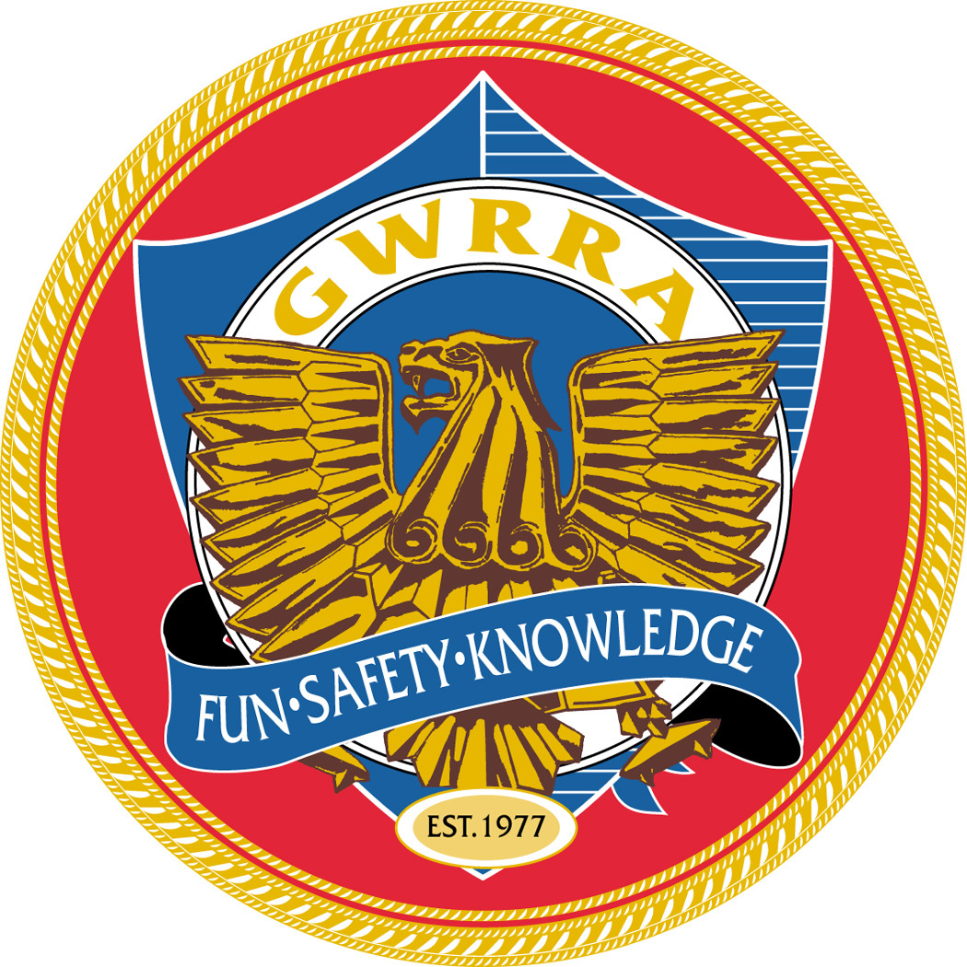

Gold Wing Road Riders Association
QUARTERLY ACTIVITY REPORT

DUE APRIL-5, JULY-5, OCTOBER-5, JANUARY-5

Please send the following information to your higher level Motorist Awareness Coordinator

Region, District or  Chapter: |  | Date:
Region, District or  Chapter MA Director: |  | GWRRA Number
Date Appointed  MA Director: |  | Expiration Date:
Number of Motorcyclist Presentations
Number of Non-motorcyclist Presentations
Number of Public Appearances, e.g. Mall or Bike Show:
Types of public appearances:
Do you need any assistance, literature, etc:
Revised June 1, 2004

